[The objective of the Software Design Description (SDD) is to describe the design of the requirements. It describes the design decisions, architectural design, and the detailed design needed to implement the software. The SDD is used as the basis for implementing the software. It provides the acquirer visibility into the design and provides information needed for software support.
SDD Template Instructions:
Throughout this template there will be many italicized text areas surrounded in brackets '[]', similar to these instructions. These areas either prompt for user entry or provide instructions for the section. Once completed, these bracketed text areas must be deleted.
If any section within this template technically does not apply for the project that section can be omitted from this document. Other areas in regular text are standard verbiage and should not require modifications.]

[Insert project name/task number]

Software Design Description

Version 1.0

[Insert approval date of document]

Document Change Record
Version Number | Date | Description
1.0 |  | Initial document

TABLE OF CONTENTS
1. Introduction 1
2. System Architecture 3
3. Components 6
3.1 [Name of application component] 6
4. [Notes] 8
Appendix A – acronym List 9
[Appendix B – Forms and Templates] 10
[APPENDIX C – DATABASE] 11
[Appendix D – Other Appendix] 16

Introduction
The Software Design Description (SDD) describes the design decisions, architectural design, and the detailed design needed to implement the software. The SDD is used as the basis for implementing the software. It provides the acquirer visibility into the design and provides information needed for software support.
This document will provide instruction and strategy for documenting the design of requirements. The SDD is used as the basis for implementing the software.
This document must include or reference requirements traceability.
Requirements Traceability
- Design to Requirements Traceability – Refer to the project's RTM or insert traceability from each design element identified in this plan to the requirements and, if applicable, software system requirements it addresses.
[Project Background - Insert project background/description and/or any specific policies, procedures.]
[Identification - Insert a full identification of the system and the software to which this document applies, including, as applicable, identification number(s), title(s), abbreviation(s), version number(s), and release number(s).]
[System Overview - Insert a brief purpose of the system and the software to which this document applies. Describe the general nature of the system and software; summarize the history of system development, operation, and maintenance; identify the project sponsor, acquirer, user, developer, and support agencies; identify current and planned operating sites; and list other relevant documents.]
[Document Overview - This Software Design Description defines the strategies necessary to accomplish the design activities associated with [Insert project name]. Design related procedural instructions are included in the Standard Operating Procedures (SOPs). Insert additional summary of the purpose and contents of this document and describe any security or privacy considerations associated with its use. Insert any project specific comments and the type of development. The remaining Software Design Description sections are organized as follows:
- Section 2. System Architecture: Describes and overview of the system, the conceptual and architectural design, interfaces and the various environments that will be used throughout the development lifecycle.
- Section 3. Components: Identifies and describes each component broken down into its parts that are described in detail.
- [Section 4. Notes: Contains general information that aids in the understanding of this document.]
- Appendix A. Acronym List: Defines the acronyms to be used on the project.
- [Appendix B. Forms and Templates: Contains the forms and templates that will be used on the project.]
- [Appendix C. Database: Describes database-wide design decisions about the database's behavioral design and other decisions affecting further design of the database broken down into its parts that are described in detail.]
- [Appendix D. Other appendices: Provides any additional information published separately for convenience in document maintenance.]]
[Reference documents - Refer to the HST Software Engineering Handbook for additional information. For additional project specific information, refer to the following documents:
- [Project Name]'s Software Development Plan (SDP)
- [Project Name]'s Configuration Management (SCM) Plan
- Add any additional relationships, if any, of the Software Design Description to related project management plans.
The following Standard Operating Procedures for design will be used on this project and are referenced in this document.
- List any project specific SOPs]

System Architecture
[This section shall be divided into paragraphs as needed to present unit-wide design decisions.]
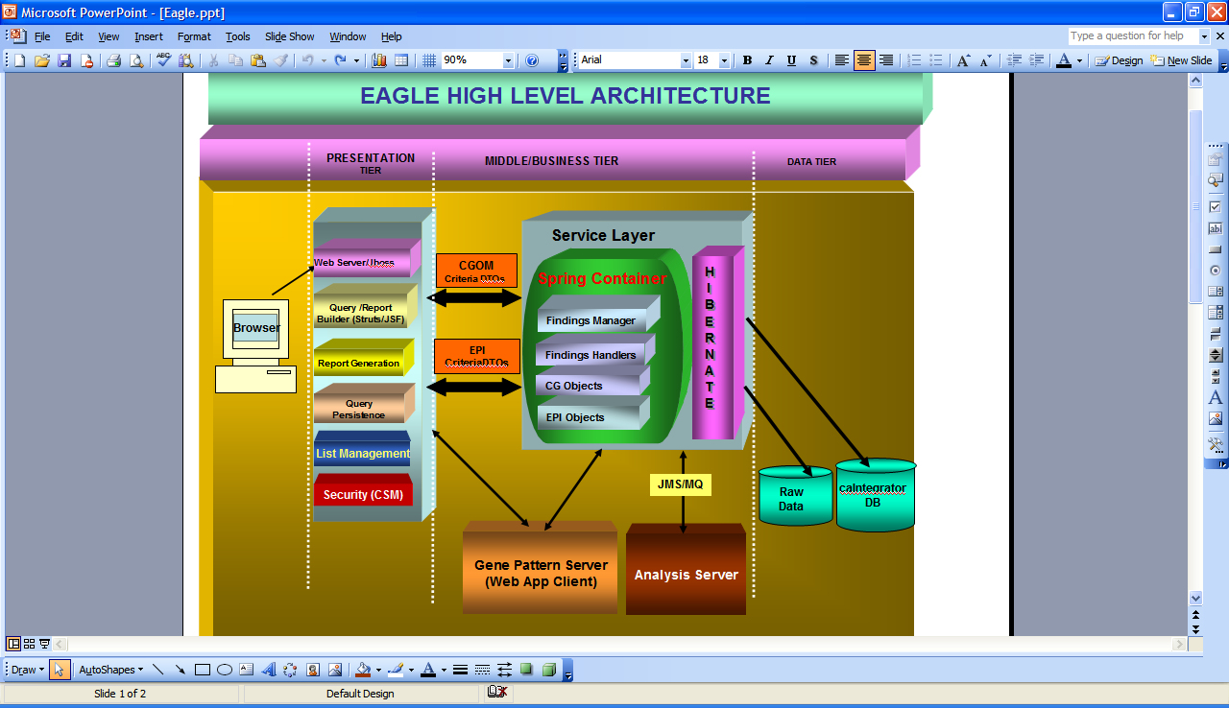
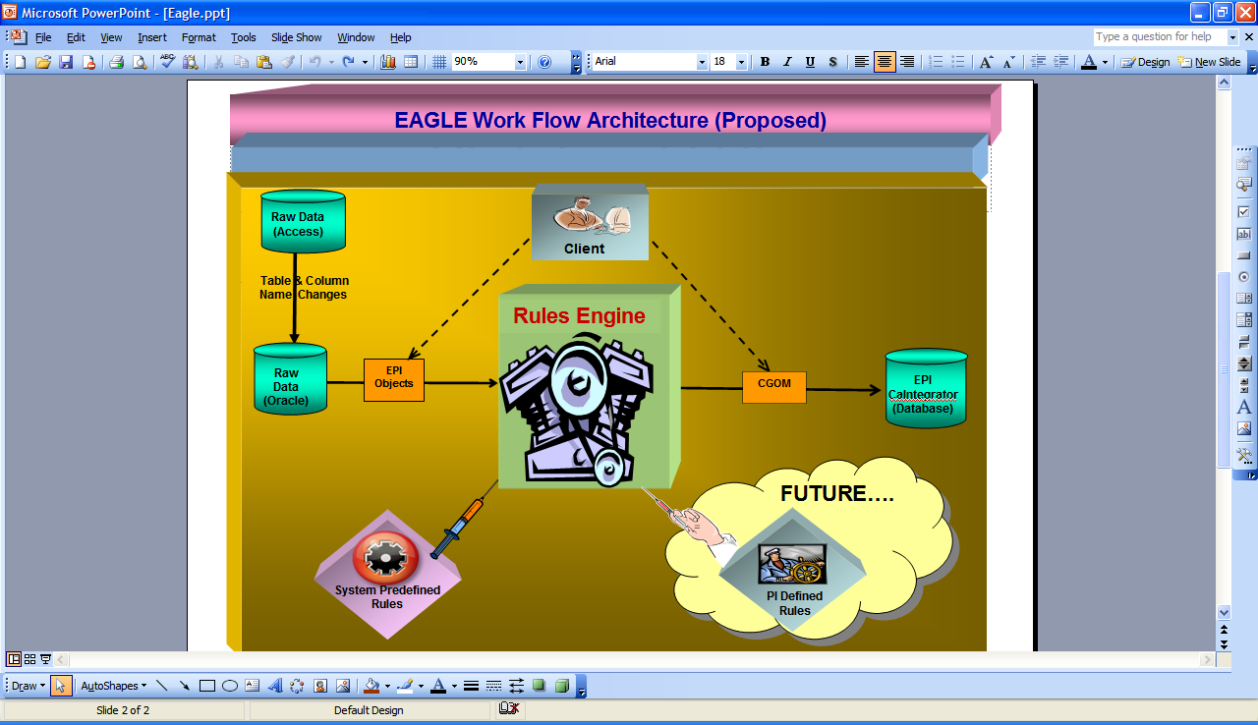

Description:
As shown in the diagram, this system consists of an application component and data processing components. There is a data processing that goes in this system. It receives raw data files (in Aceess format) for epidemiology data. Then derived data is produced from this raw data set based on certain rules (using Rules Engine). Then this derived data is mapped against CGOM and stored in caIntegrator ware house.
In phase I of the project this derived data also provided by the external customers. This is produced by using some SAS scripts. And the goal in second phase is that making these rules execute dynamically so that PIs can apply their own rules to get derived data (in the form of CG-OM objects and reports) from within the application. At present a small proto type was developed to demonstrate converting Raw data in to Derived data (using Drules Rules Engine). Further evaluation will be done in Phase II and select an appropriate rules engine that will be plugged in to the application so that PIs can apply their own rules/definitions to analyze the data. Additionally, each PI will be able to define/save persist their rules.

[Database Design - Reference the Database Design if applicable.]
[System Security - Insert the high level approach to meeting safety, security, and privacy requirements.
- Network Level - Insert the selected approach to meeting safety, security, and privacy requirements at the network level.
- Database Level - Insert the selected approach to meeting safety, security, and privacy requirements at the database level.
- Application Level - Insert the selected approach to meeting safety, security, and privacy requirements at the application level.]

Components
[This section shall describe each software unit of the requirement. If part of all of the design depends upon system states or modes, this dependency shall be indicated. If design information falls into more than one paragraph, it may be presented once and referenced from the other paragraphs. Design conventions needed to understand the design should be presented or referenced. Software units that are databases, or that are used to access or manipulate databases, are described in Appendix C. Reference the Database Design if applicable.
This is a reference for the programmer to consult. Each component will be broken down here into its parts that are described in detail. Diagrams should be included here. Use an appropriate naming convention for parts of a component. Structure this section according to the system design. ID number or requirements number may name components. Document detailed design information.
Section 3.1 will be repeated for each application component. The first component will be Section 3.1; the second component will be section 3.2 etc. Each site description will follow the same outline as indicated in section 3.1]

[Name of application component]
[This paragraph shall identify a requirement by a project-unique identifier and shall describe the unit. The description shall include the following information, as applicable. Alternatively, this paragraph may designate a group of requirements and identify and describe the requirements in subparagraphs. Requirements that contain other requirements may reference the descriptions of those requirements rather than repeating information.
Give the name of the component. The names should be related to the major component of which they are part. Describe each high level component. The main information given below relates to the 'external' aspects of the components that are used to specify it as a black box. Some of the items listed below may not be relevant - if so you can omit them but preserve the order given. Structure this section according to the design.]
[Type - State whether the component is a module, a file, a program etc.]
[Purpose - Insert the purpose of the component, tracing it to the software requirements.]
[Function - Describe what the component does.]
[Subordinate - List the immediate children.]
[Dependencies - Describe any constraints, limitations, or unusual features in the design of the software unit.]
[Preconditions - Describe any preconditions for using the component.]
[Interfaces - Define the control and data flow to and from the component. If the software unit contains, receives, or outputs data, a description of its inputs, outputs, and other data elements and data element assemblies, as applicable. Data local to the software unit shall be described separately from data input to or output from the software unit.]
[Graphics- Include screenshots where appropriate to show how a screen or graphic will look.]
[Resources - List the resources required, such as displays and printers.]
[References - Give references of any documents needed to understand the component.]
[Processing - Describe the control and data flow within the component using pseudo code or a PDL. Describe when the software unit contains logic, the logic to be used by the software unit, including, as applicable: 1) Conditions in effect within the software unit when its execution is initiated; 2) Conditions under which control is passed to other software units; 3) Response and response time to each input, including data conversion, renaming, and data transfer operations; 4) Exception and error handling 5) Sequence of operations and dynamically controlled sequencing during the software unit's operation, including:
- The method for sequence control
- The logic and input conditions of that method, such as timing variations, priority assignments
- Data transfer in and out of memory
- The sensing of discrete input signals, and timing relationships between interrupt operations within the software unit
When the software unit consists of or contains procedural commands a list of the procedural commands and reference to user manuals or other documents that explain them.]
[Data - Define in detail the data internal to components.]
[Space Estimates - Identify space estimates, if applicable.]
[Impact to existing components]
[System Security - Insert the component level approach to meeting safety, security, and privacy requirements
- Network Level - Insert the selected approach to meeting safety, security, and privacy requirements at the network level
- Database Level - Insert the selected approach to meeting safety, security, and privacy requirements at the database level
- Application Level - Insert the selected approach to meeting safety, security, and privacy requirements at the application level]

[Notes]
[Insert any general information that aids in understanding this document (e.g., background information, glossary, and rationale). This section shall include a list of any terms and definitions needed to understand this document.]

Appendix A – acronym List
[Insert an alphabetical listing of all acronyms, abbreviations, and their meanings as used in this document.]
Acronym | Description
[????] | [Insert Project Name acronym]
[????] | [Insert Project all other project Software Design Description specific acronyms and resort the table]
CI | Configuration Item
DBA | Database Administrator
MS | Microsoft
PM | Project Manager
RM | Requirements Manager
RTM | Requirements Traceability Matrix
SCM | Software Configuration Management
SDD | Software Design Description
SDLC | Software Development Lifecycle
SDP | Software Development Plan
SE | Software Engineering
SEPG | Software Engineering Process Group
SPE | Software Product Engineering
SM | Software Manager
SOP | Standard Operating Procedure
SPI | Software Process Improvement
SQA | Software Quality Assurance
SRS | Software Requirement Specification
SW | Software
TM | Test Manager

[Appendix B – Forms and Templates]
[Attach any design forms or templates used on the project. Use dynamic links; do not paste the forms and template in this file/document.]

[APPENDIX C – DATABASE]
Overview – This section shall describe any changes made to the database/back end. All changes should be maintained in CCR/Release folders in PVCS. The entity changes will be updated in ER tool (Erwin/Oracle Designer etc) at the implementation time. The database changes will be updated in PVCS at the time of implementation. Examples of database changes include:
- Table
  - New Table
    - Purpose:
    - Schema:
    - Create Script including indexes, constraints and grants, sequences, snapshots:
    - Type of Table: normal, index organized, materialized view etc.
    - Data expected in 1 year:
    - Data Retention Period: Will data be archived from time to time?
    - Are there data that need to be loaded into the table at the creation time? What and where are the scripts to load the data?
    - Location of scripts, data etc.
  - Modifications to Old Table
    - Purpose:
    - Schema:
    - Modification Script (include changes to the storage clause, indexes, sequences and grants as well):
    - Procedure to Modify: Describe the process to modify the old table; for example if adding a column, simply provide the script to add the column; if modifying the data type of a column, provide the necessary steps like export, drop recreate and import clearly
    - Data Modifications: Will the modified table require modifications to data or require insertions of additional data? Provide scripts as required.
    - Location of scripts, data etc.
  - Obsolete Tables:
    - Reason the object has become obsolete?
    - Schema:
    - Should the data be retained for any reason and for how long? This will help decide whether to store an export file on server or tape. Regardless of the retention period, the data should be retained online until the Release has been implemented and approved.
    - Script to delete table, views build upon the table, synonyms for the table and any referential integrity
    - Location of Script:
- Data Modifications
  - Purpose:
  - Schema:
  - Script to add/modify data (include changes to storage clause, indexes and grants as well as necessary statements to disable and enable constraints and triggers before and after the data modifications):
  - Step by step process to modify the data:
- Stored Objects (Trigger, Procedure, Package, Function, View)
  - Purpose:
  - Obsolete/New/Modification Description:
  - Will the stored objects change the data retention/growth of any table? If so, describe the change.
  - Location of Scripts:
- Database Links
  - Purpose:
  - New/Modification/Obsolete:
    - If new or modification: is the database link private/public? If the database link is public, state the justification. If a public database link is created, ensure the schema used in the link will not compromise security.
  - For modified or obsolete database links, are there any outside users of the link that need to be notified?
  - Location of Scripts:
- Init.ora
  - Purpose:
  - Addition/Modification
  - Temporary? If the addition/modification is temporary, what is the time period?
  - Expected Results: For example, will this addition/modification change the performance?
  - Location of new Init.ora file & distribution:
  - Comments:
- Listener.ora
  - Purpose:
  - Modification:
  - Temporary: for example, is the change required to troubleshoot an issue by placing a trace level?
  - If adding more listeners or changing ports, are there any users that need to be notified to reference the new ports?
  - Location of new Listener.ora file & distribution:
- Tnsnames.ora
  - Purpose:
  - Addition/Modification/Deletion:
  - Location of new tnsnames.ora file:
- Server Batch jobs:
  - New
    - Purpose:
    - Command File:
    - Owner:
    - Privileges required to execute batch job:
    - Schedule:
    - Expected length of execution? Will the new length interfere with other command files/backups?
    - Maintenance of log files generated by command file: will the command file maintain its own log files or is there another command file that maintains all log files on the server?
    - Location of command file:
  - Modification
    - Purpose:
    - Modified Command File:
    - Schedule change?
    - Change in length of execution? If the execution time increases, will there be any interference to other command files/backups?
    - Location of command file:
  - Obsolete
    - Purpose:
    - Name of Command file and any other scripts called by command file:
- Oracle jobs:
  - New
    - Purpose:
    - Name of sql package/procedure or external script:
    - Owner:
    - Privileges required to execute job:
    - Schedule:
    - Expected length of execution? Will the new length interfere with other jobs backups?
    - Maintenance of log files/tables generated by job: will the job maintain its own log files/tables or is there another job that maintains all log files/log tables in the database?
  - Modification
    - Purpose:
    - Modified sql code:
    - Schedule change?
    - Change in length of execution? If the execution time increases, will there be any interference to other jobs/backups?
  - Obsolete
    - Purpose:
    - Name of job and any other scripts called by the job:

- Arvhive Log File Maintenance:
  - Purpose:
  - Change in the maintenance schedule or retention period?
  - Is there sufficient space on disk to support the change?
- Storage Maintenance:
  - Of all the data modifications, new tables and retention changes for this CCR/Release, consider the availability of resources in the following areas:
    - Tablespace: Does the tablespace have enough space to capture the new data?
    - If datafiles need to be added/resized, are there enough space on the disks?
    - Will the generation of redo log files change thus changing the amount of archive log files that are kept on line? If yes, then is there enough disk space on the server?

[Appendix D – Other Appendix]
[Appendixes may be used to provide information published separately for convenience in document maintenance (e.g., charts, classified data). As applicable, each appendix shall be referenced in the main body of the document where the data would normally have been provided. Appendixes may be bound as separate documents for ease in handling. Appendixes shall be lettered alphabetically (A, B, etc.).]

